Supporting Information Appendix:

Evaluating drivers of spatiotemporal changes in the condition of Eastern Baltic cod

Max Lindmarka,1, Sean C. Andersonb, Michele Casinia

a Swedish University of Agricultural Sciences, Department of Aquatic Resources, Institute of Marine Research, Turistgatan 5, 453 30 Lysekil, Sweden

b Pacific Biological Station, Fisheries and Oceans Canada, Nanaimo, BC, Canada

c University of Bologna, Department of Biological, Geological and Environmental Sciences, Via Selmi 3, 40126 Bologna, Italy

1 Author to whom correspondence should be addressed. Current address:

Max Lindmark, Swedish University of Agricultural Sciences, Department of Aquatic Resources, Institute of Marine Research, Turistgatan 5, 453 30 Lysekil, Sweden, Tel.: +46(0)104784137, email: max.lindmark@slu.se

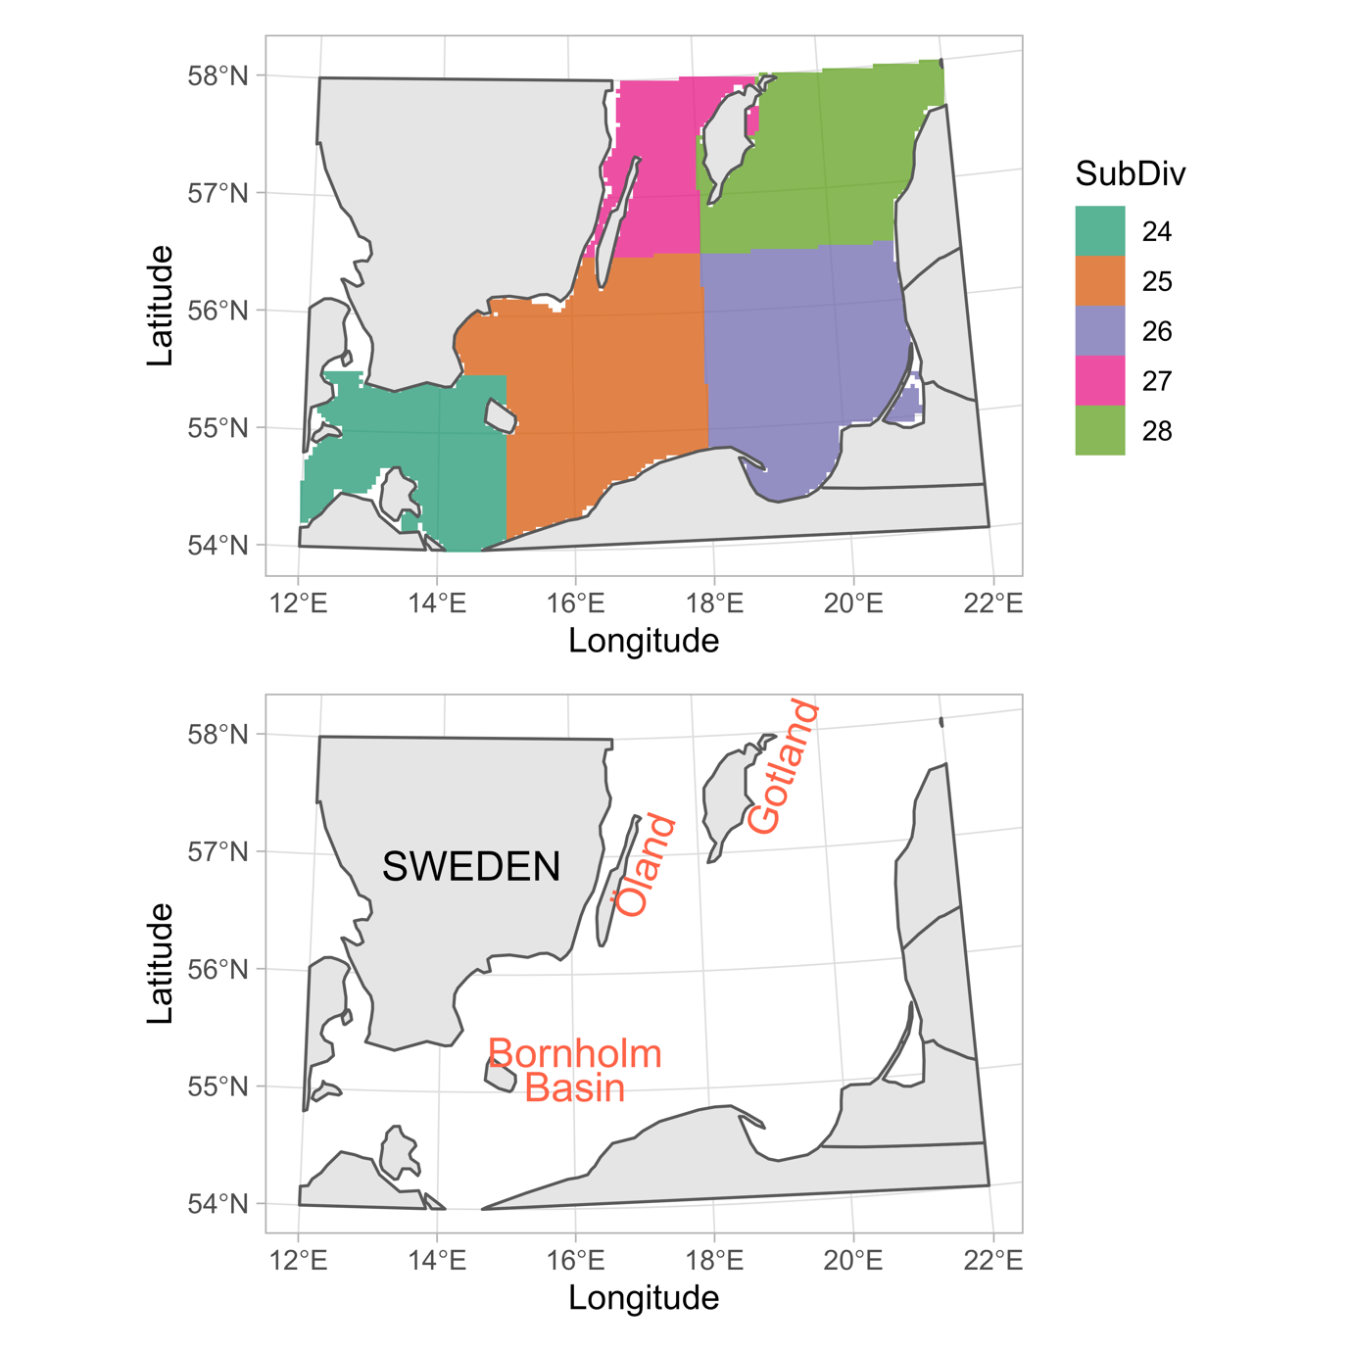

Fig. S1. Map of ICES subdivisions (top) with mentioned locations in manuscript in text in the bottom panel.

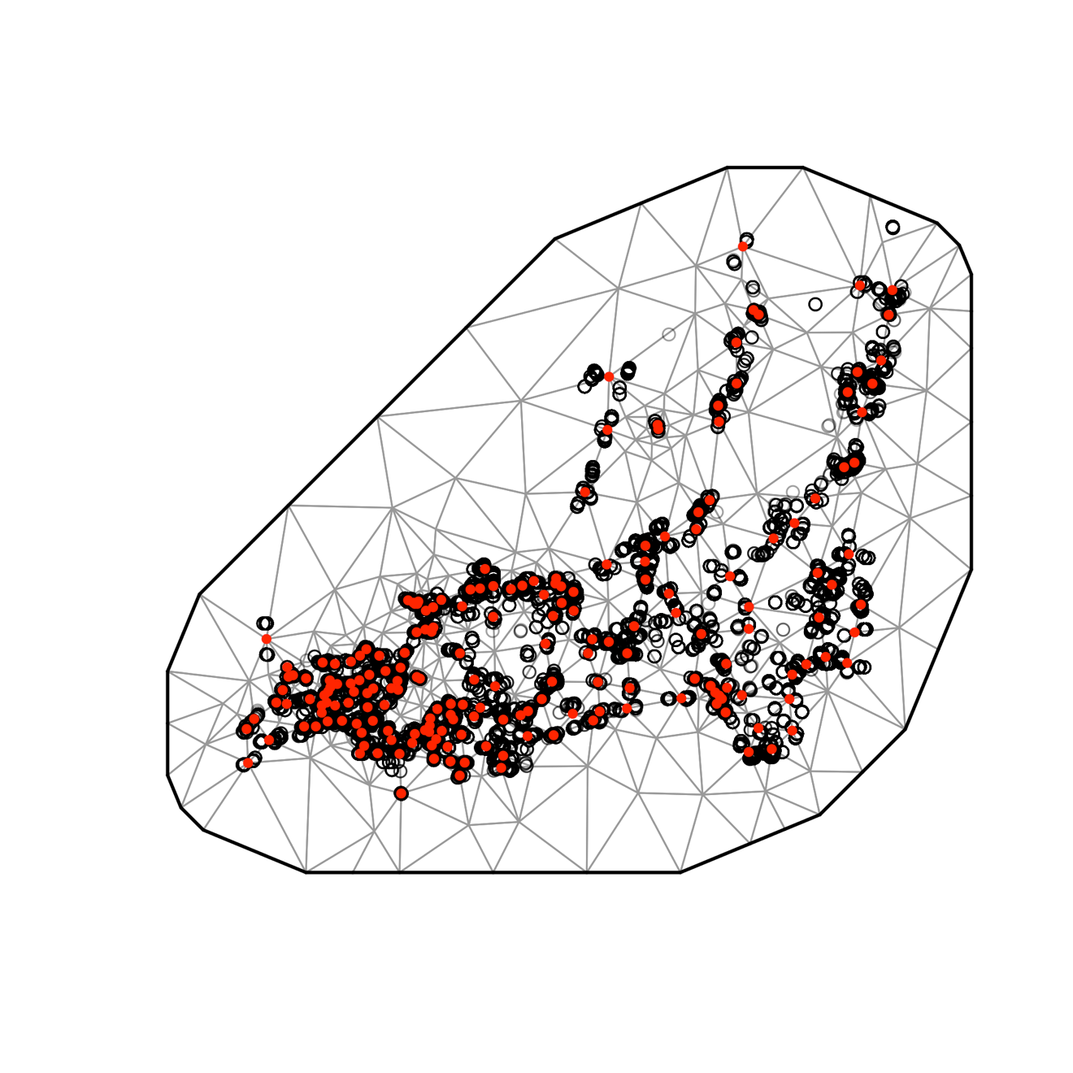

Fig. S2. SPDE mesh for condition model (200 knots).

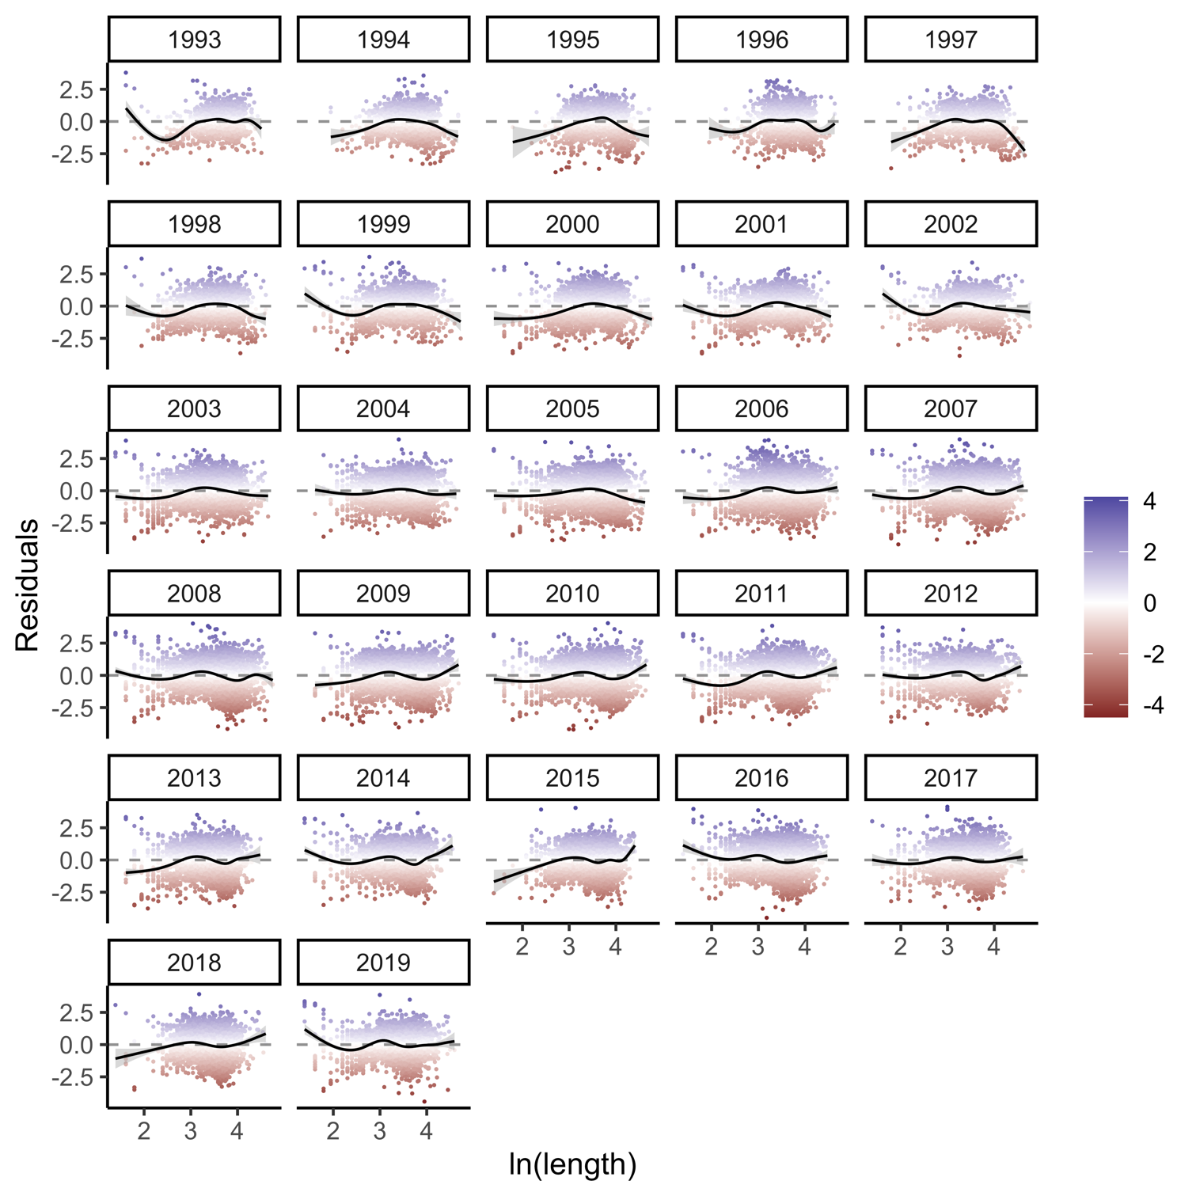

Fig. S3. Residuals from the condition model plotted against length for each year.

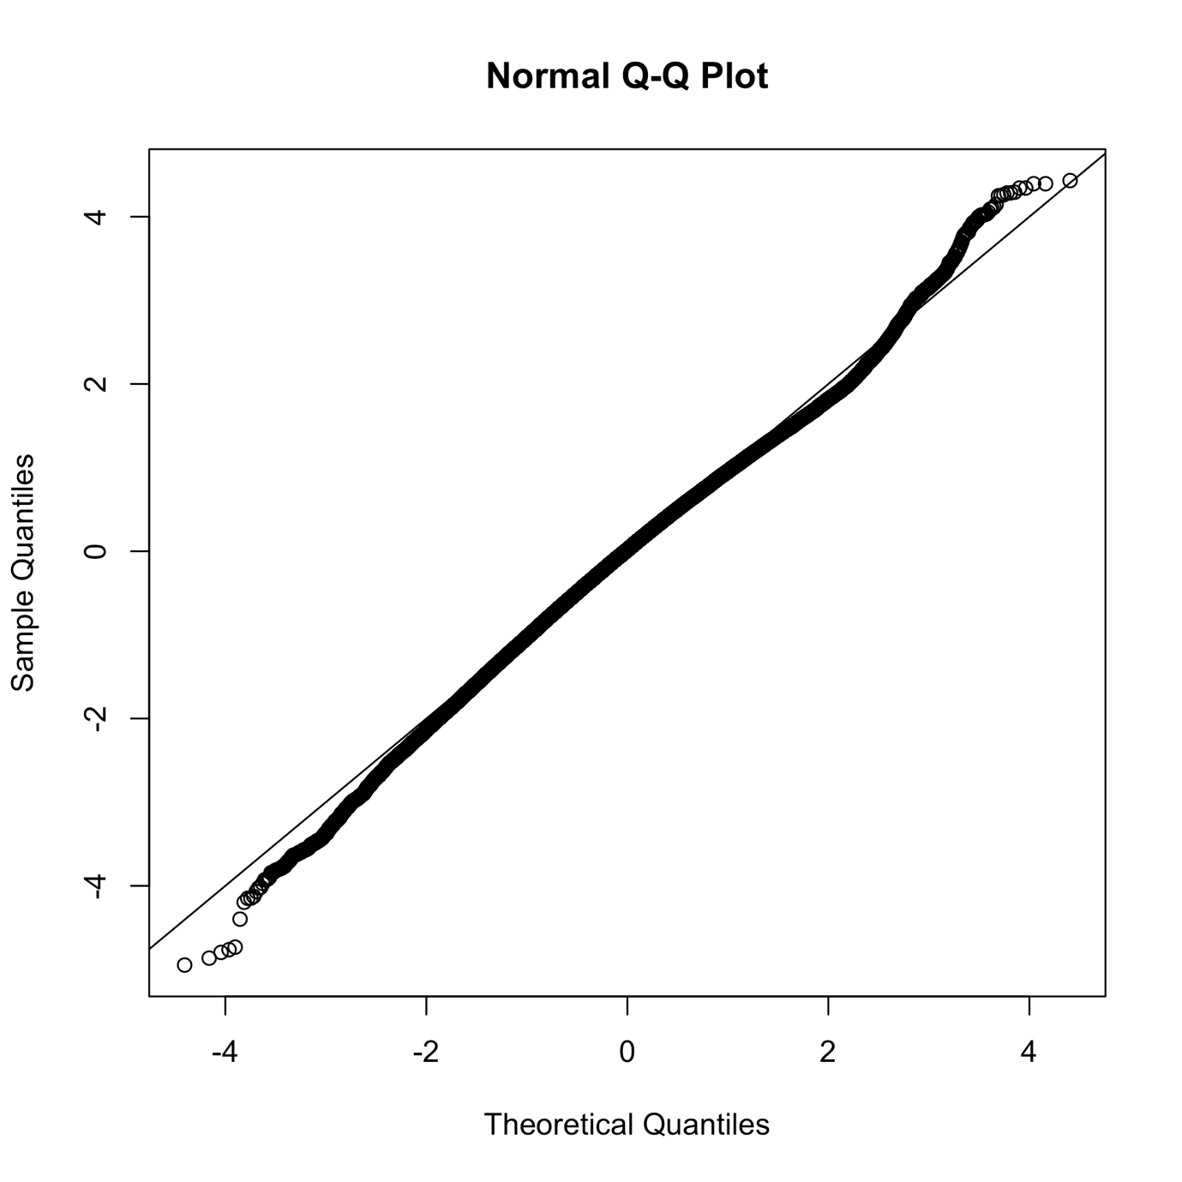

Fig. S4. QQ plot of condition model.

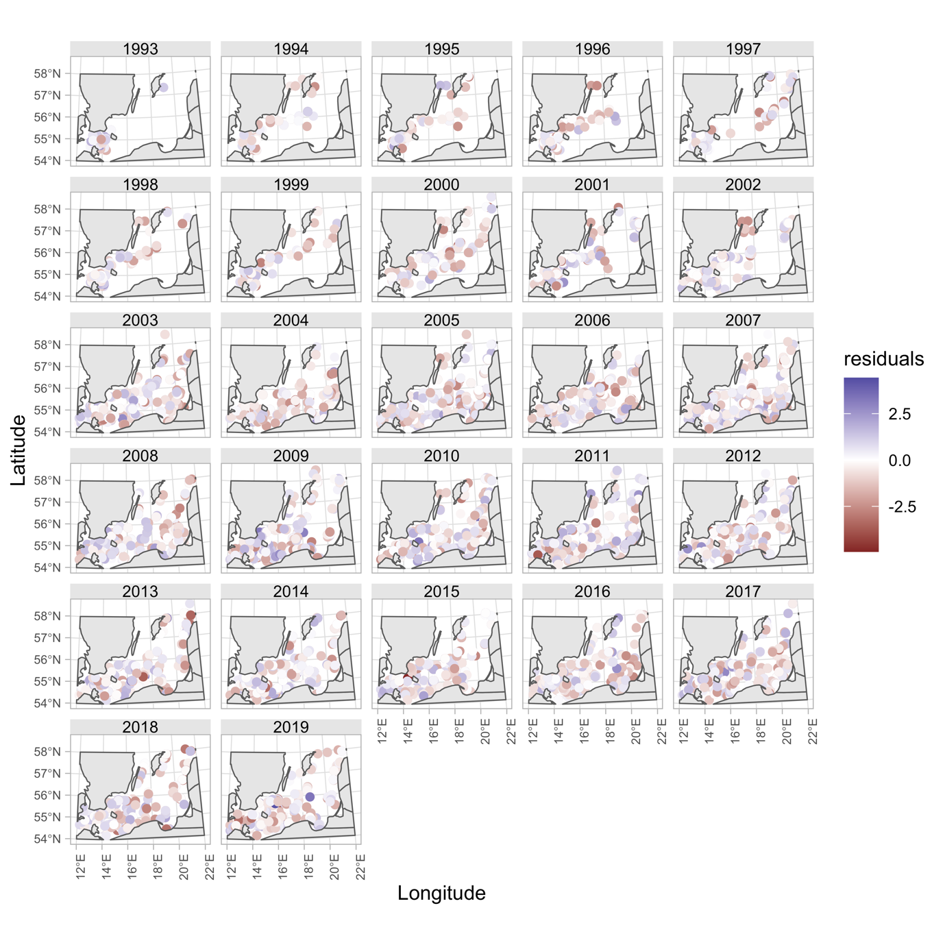

Fig. S5. Condition model residuals plotted in space.

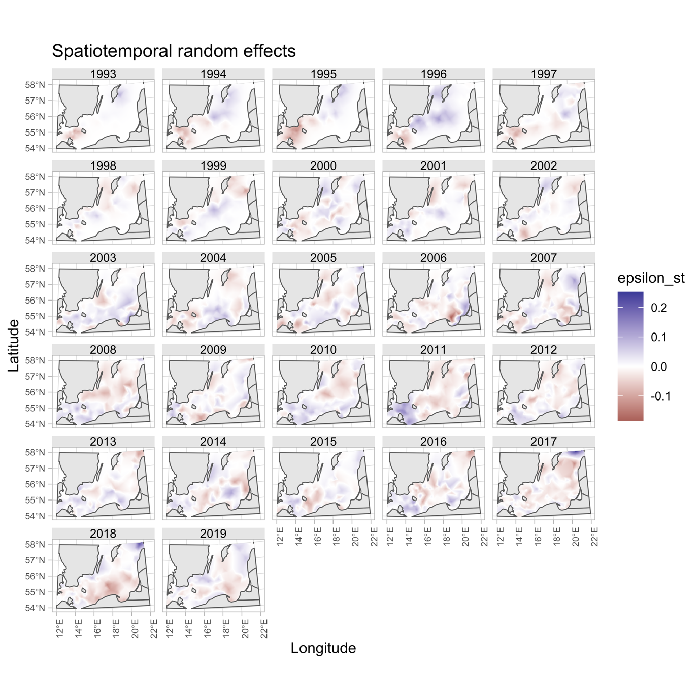

Fig. S6. Spatiotemporal random effects for the condition model.

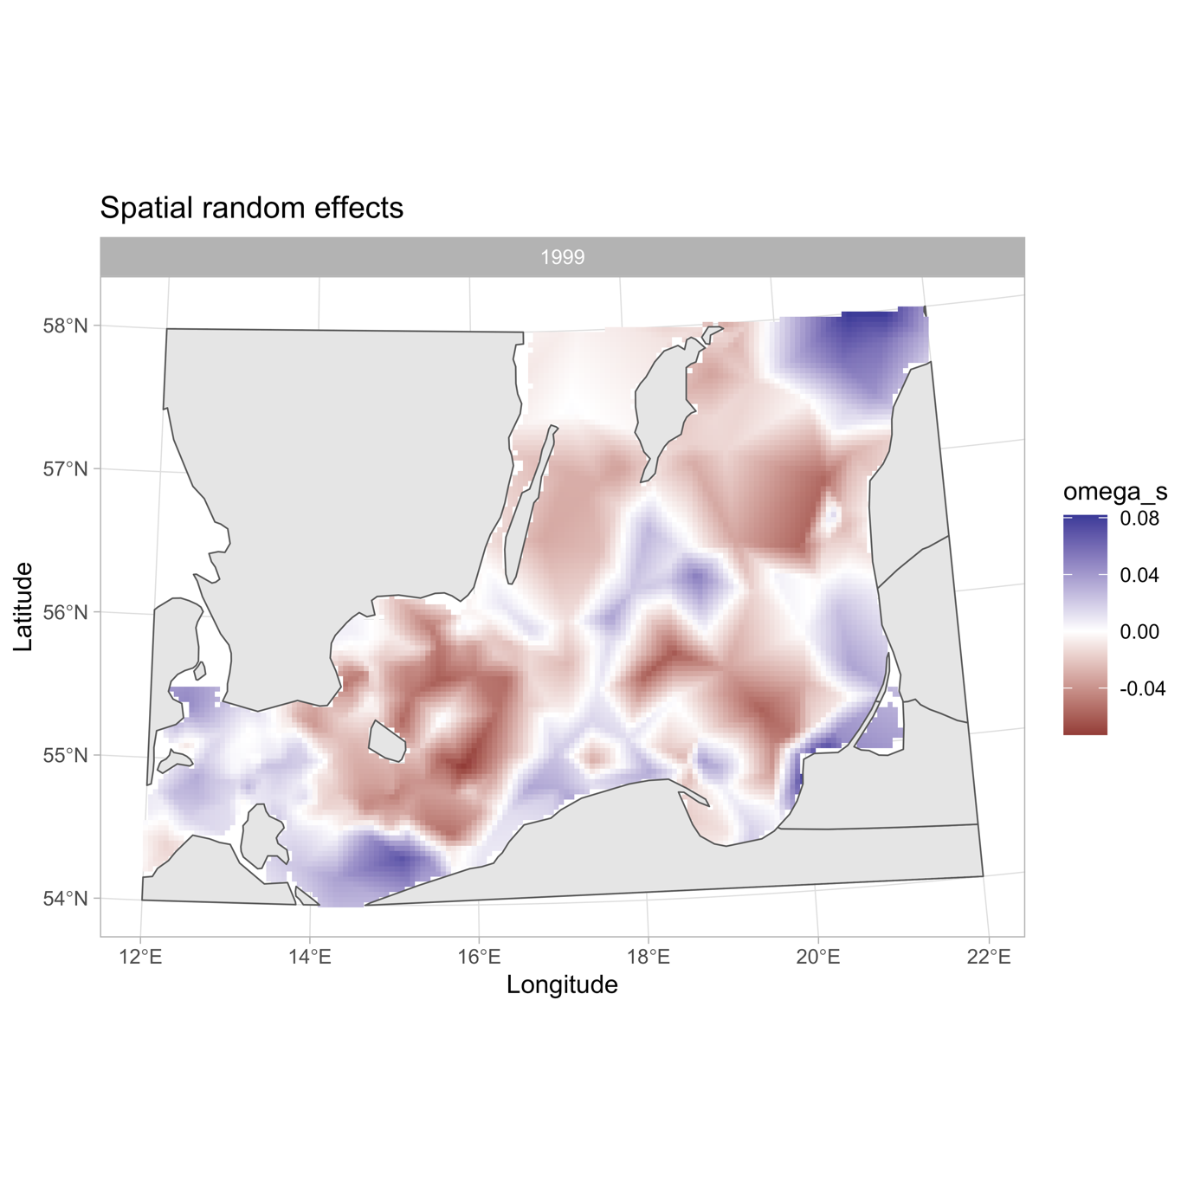

Fig. S7. Spatial random effects for the condition model.

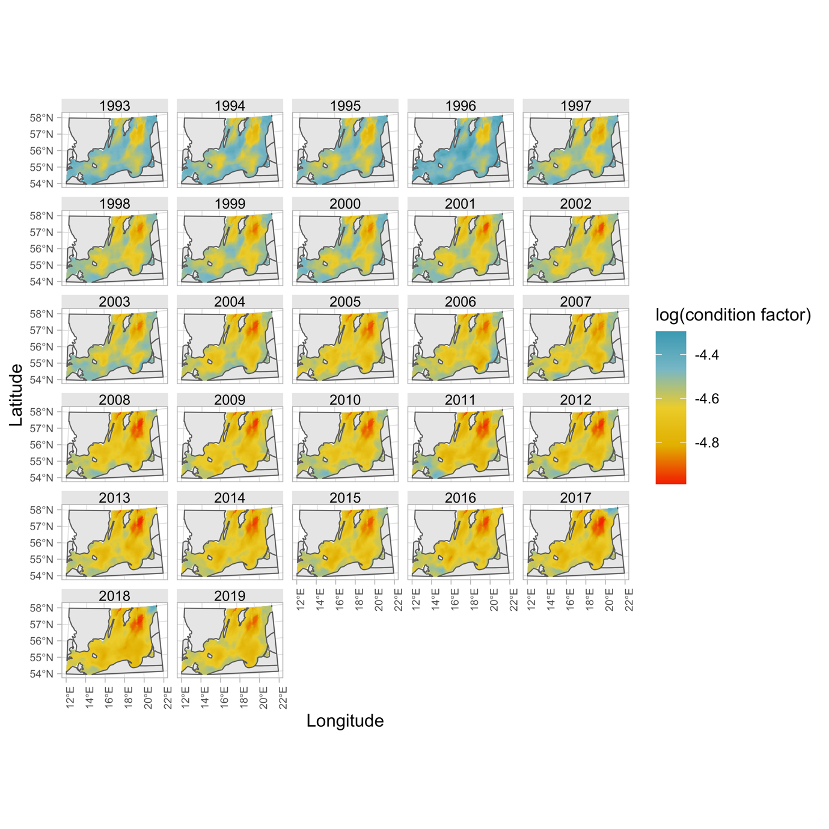

Fig. S8. Predicted log condition factor in space and time with all covariates are zero except depth, oxygen and temperature.

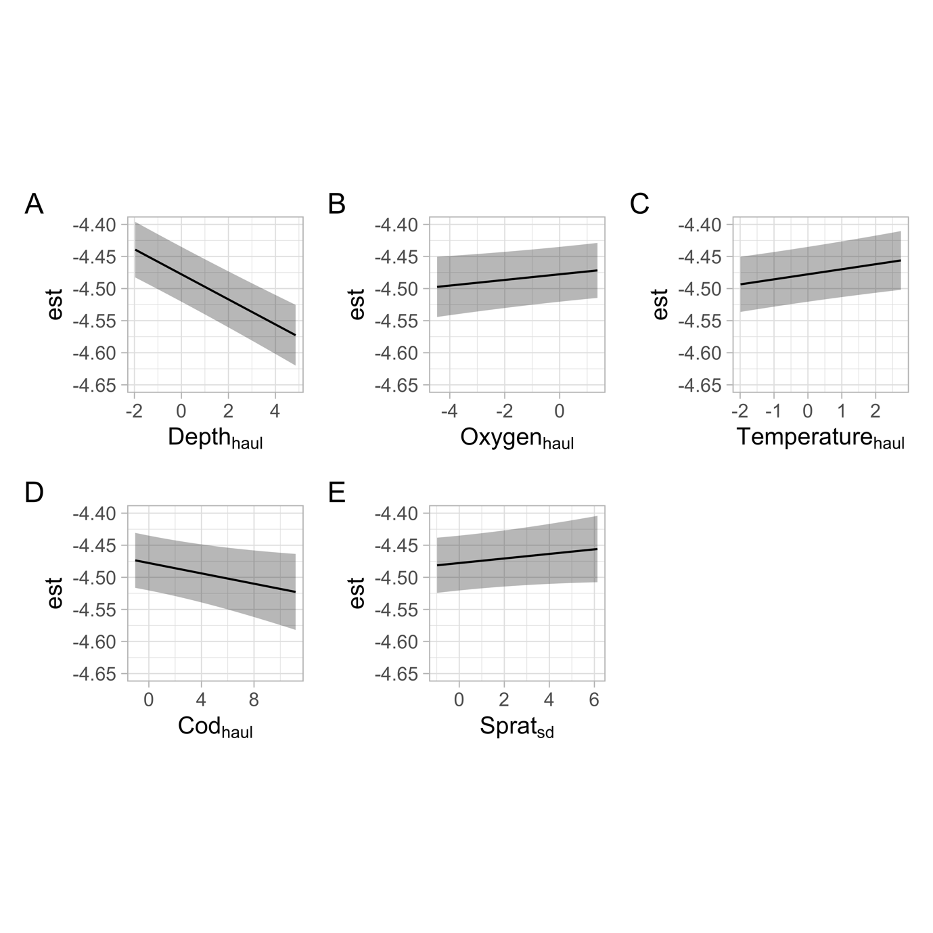

Fig. S9. Marginal effects from the condition model for covariates with the largest absolute effect sizes.

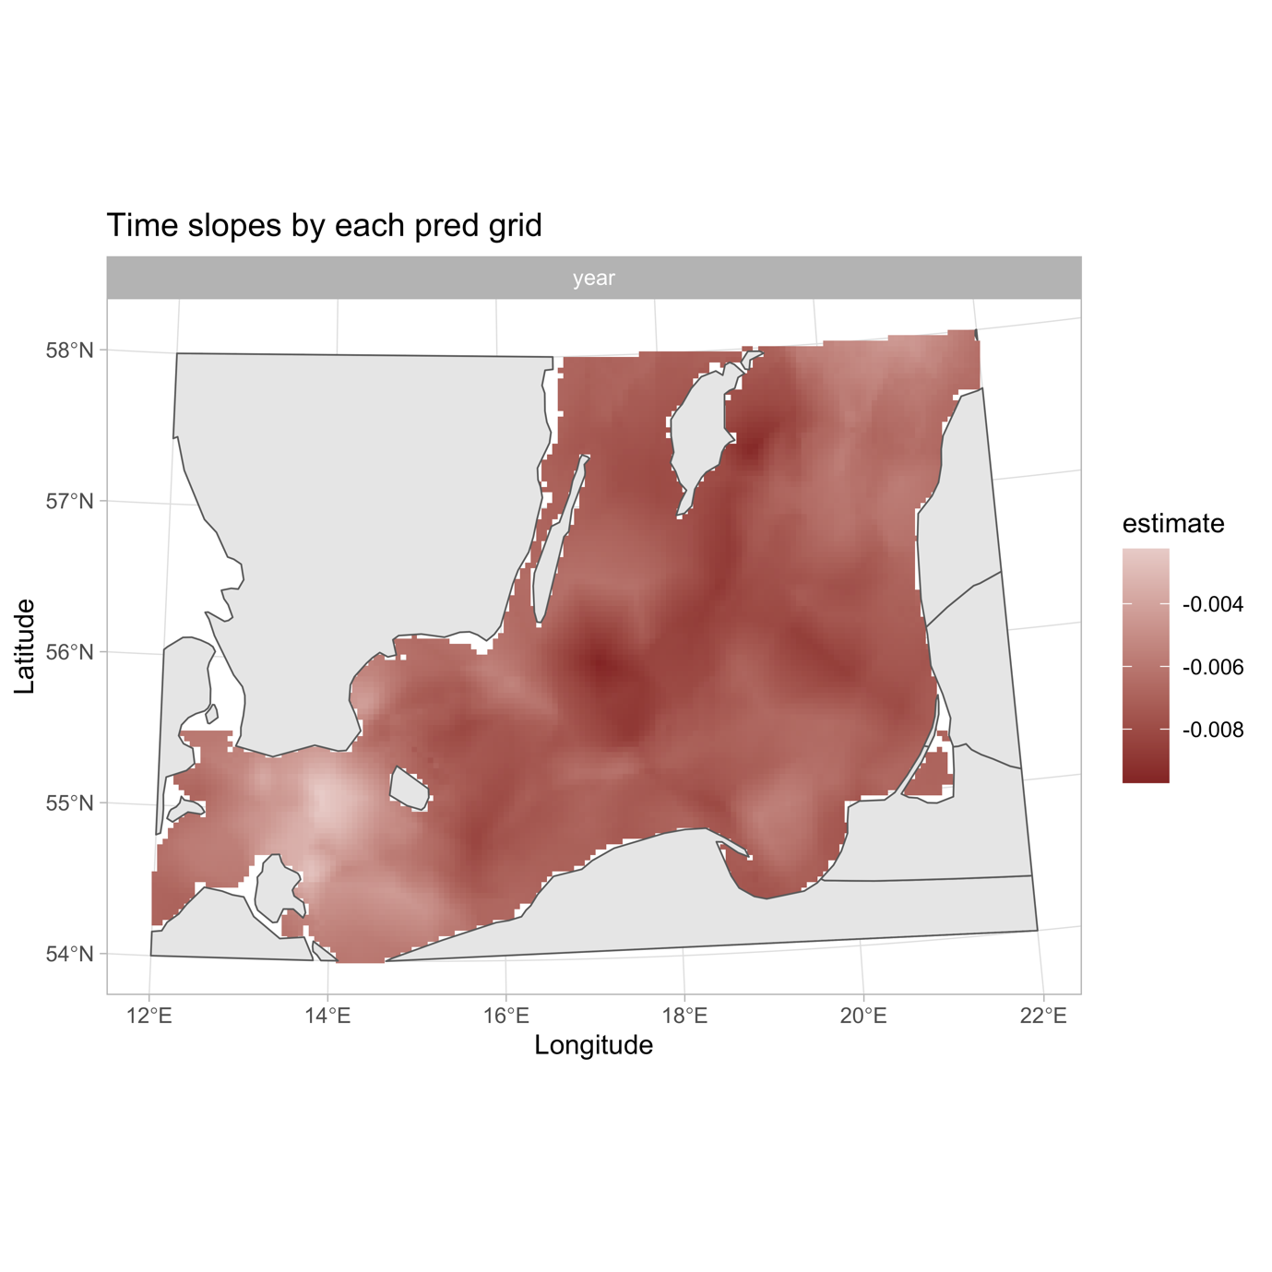

Fig. S10. Predicted slopes from a linear regression of condition factor (predicted onto the grid with all covariates set to zero except depth, oxygen and temperature) as a function of time (years) per grid cell.

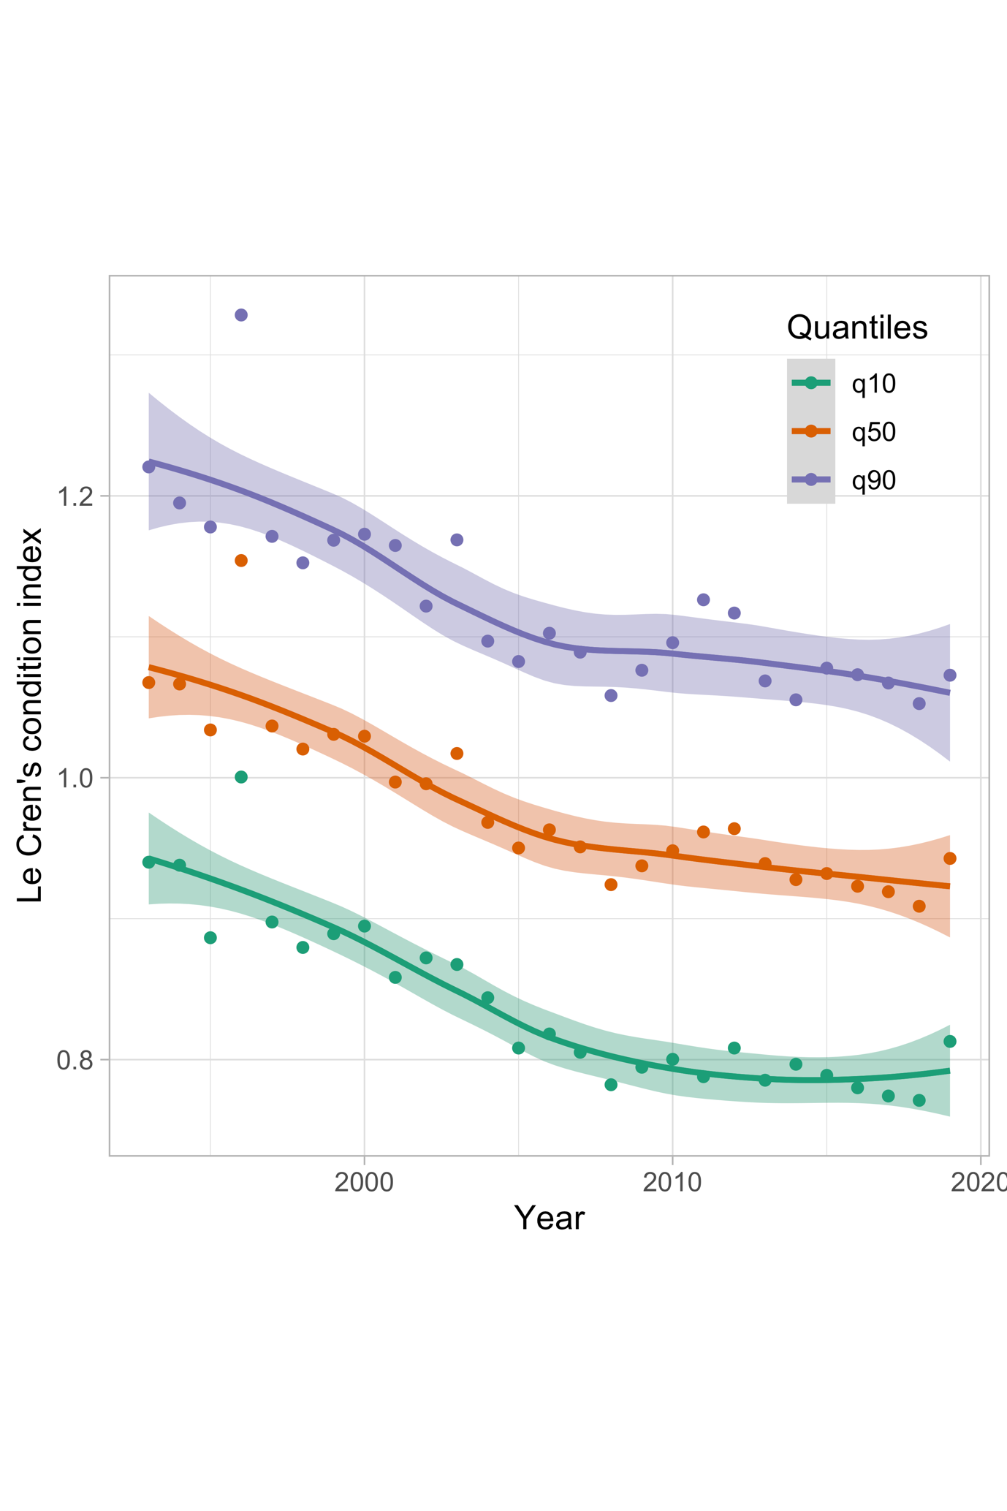

Fig. S11. 1st, 5th and 9th decile of the Le Cren’s condition index over year (points) and a fitted GAM with $k=3$ (lines) with 95% confidence intervals (bands). This illustrates that the average decline in body condition is not driven only by a worsening of the condition of cod already in bad condition or the cod in good condition, but an overall decline.

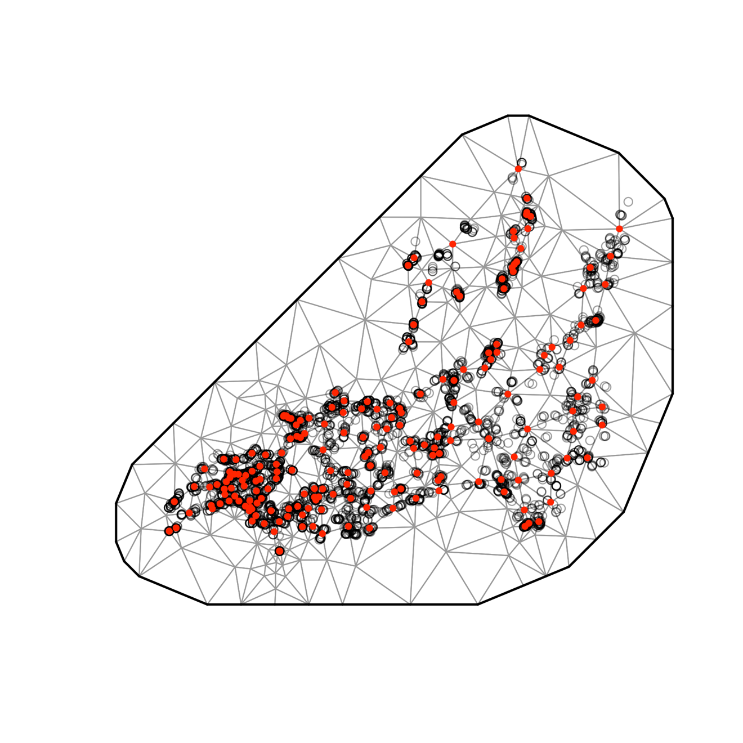

Fig. S12. SPDE mesh for density model (200 knots).

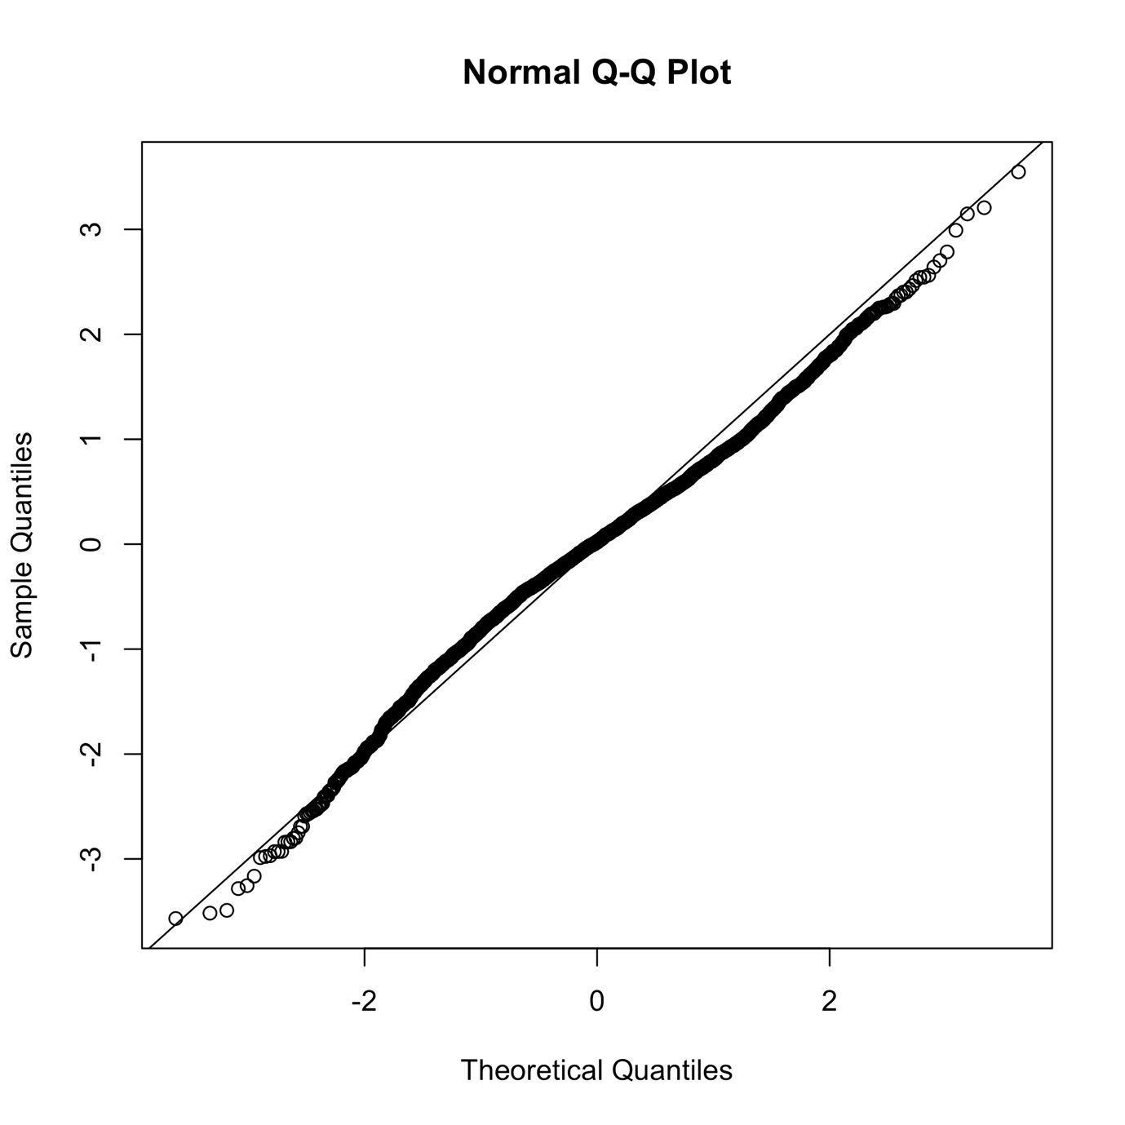

Fig. S13. QQ plot of density model.

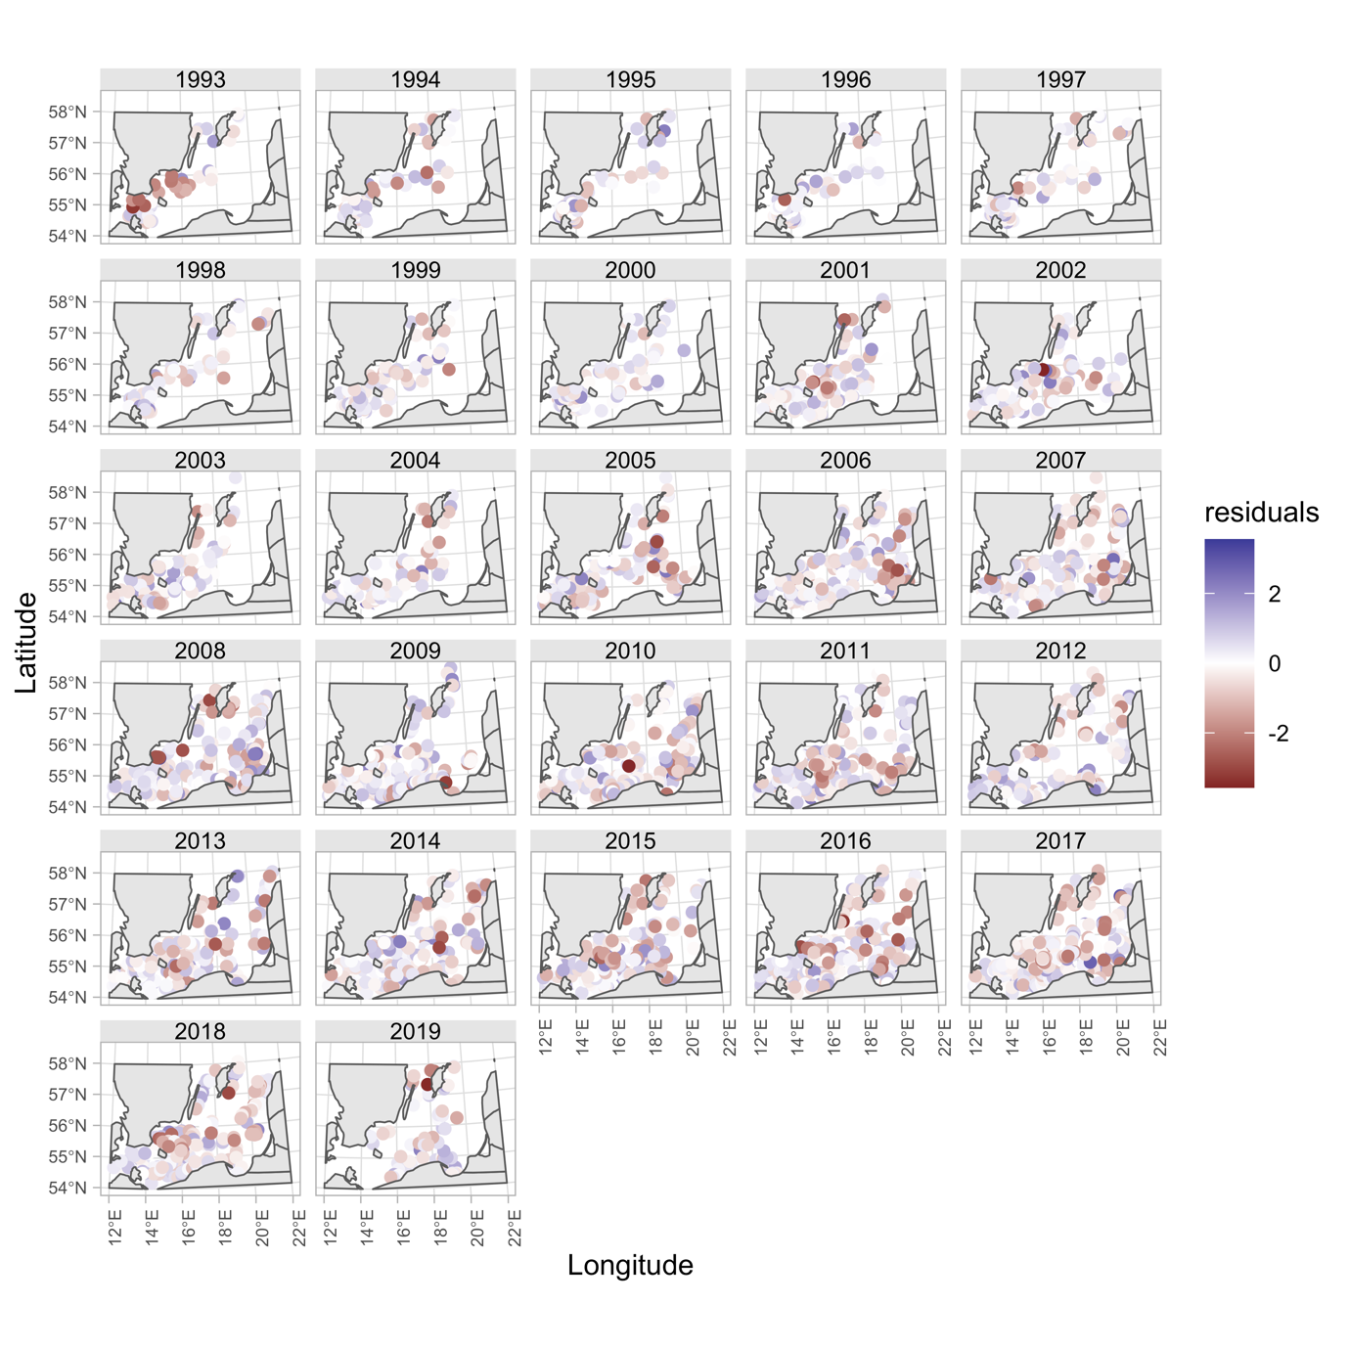

Fig. S14. Density model residuals plotted in space

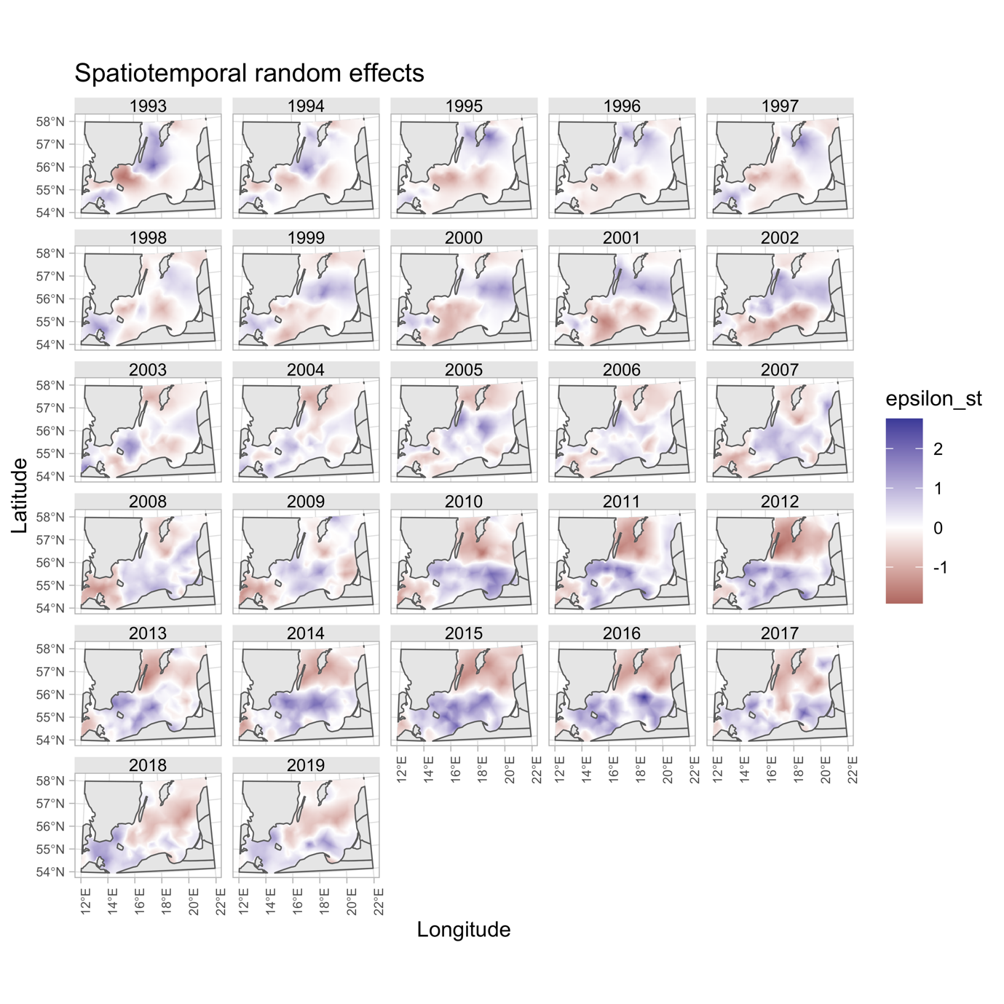

Fig. S15. Spatiotemporal random effects for the density model

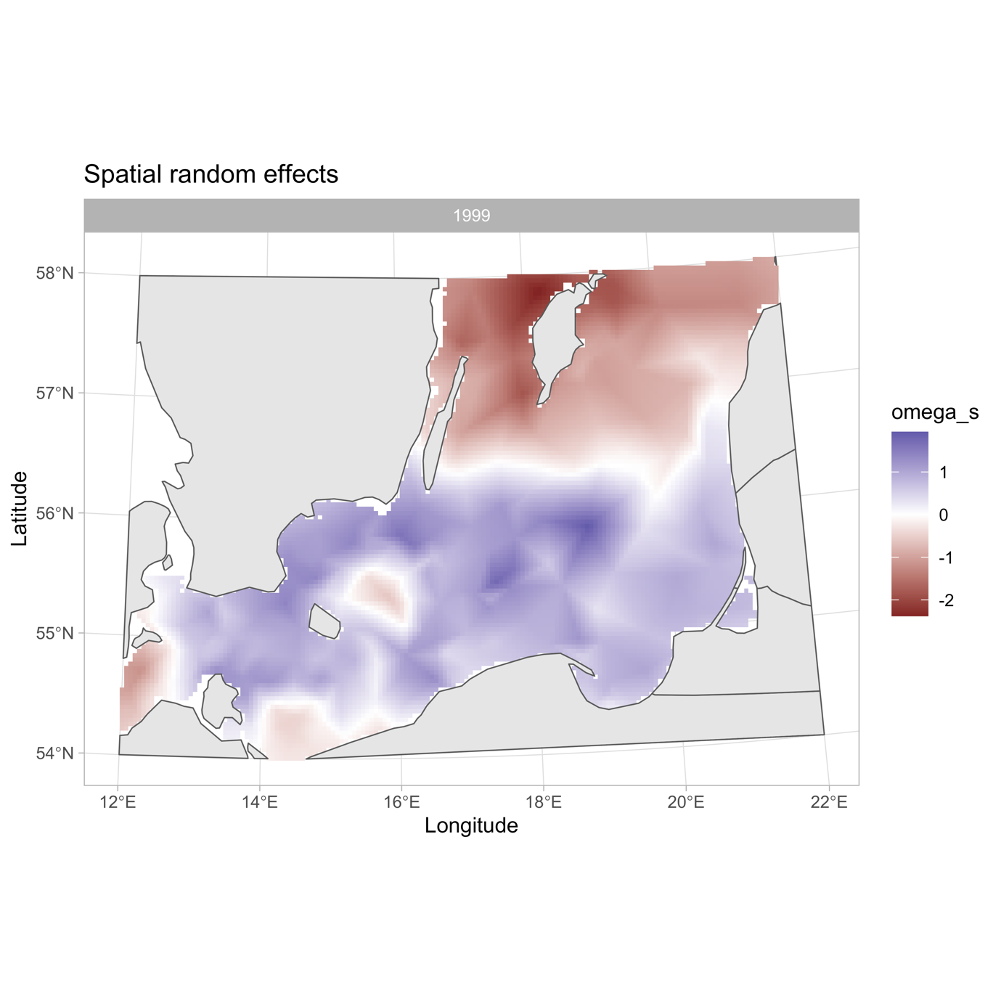

Fig. S16. Spatial random effects for the density model.

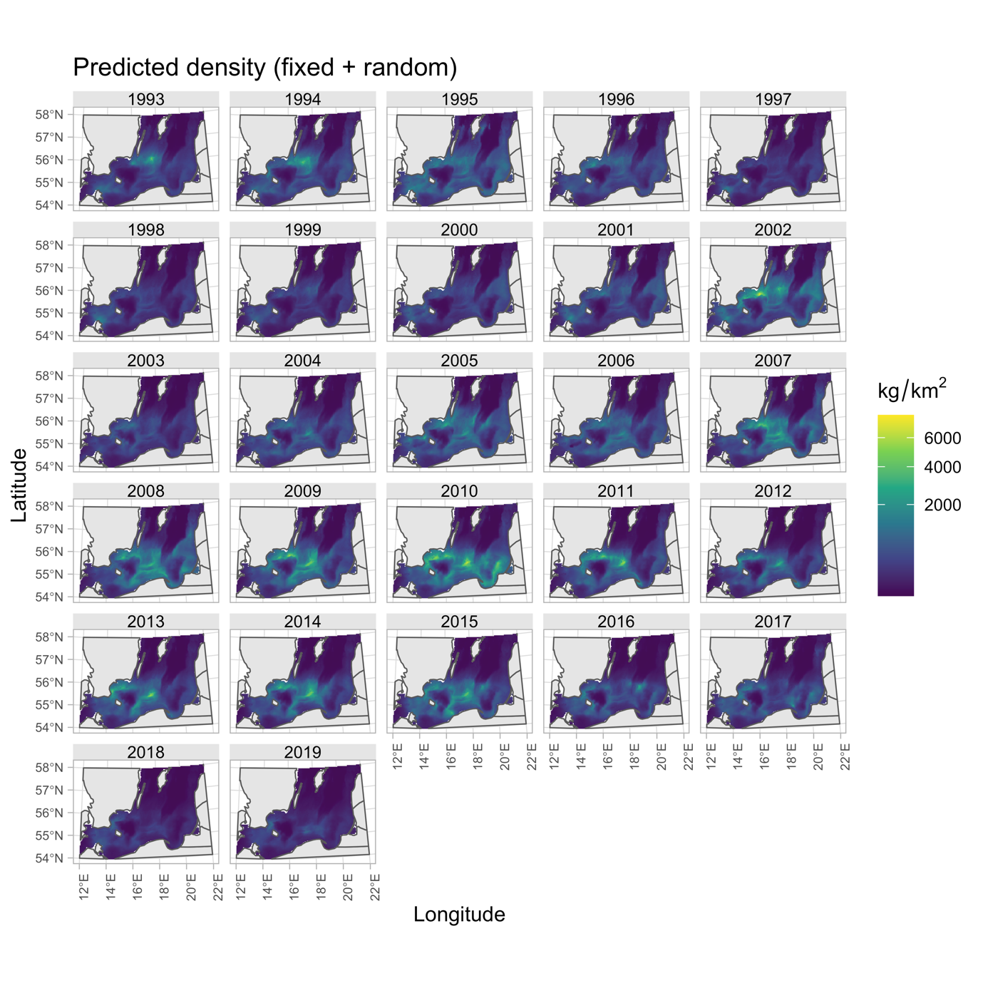

Fig. S17. Predicted density in space and time with covariates depth, oxygen and temperature.

Fig. S18. Placeholder for marginal effects for density model.

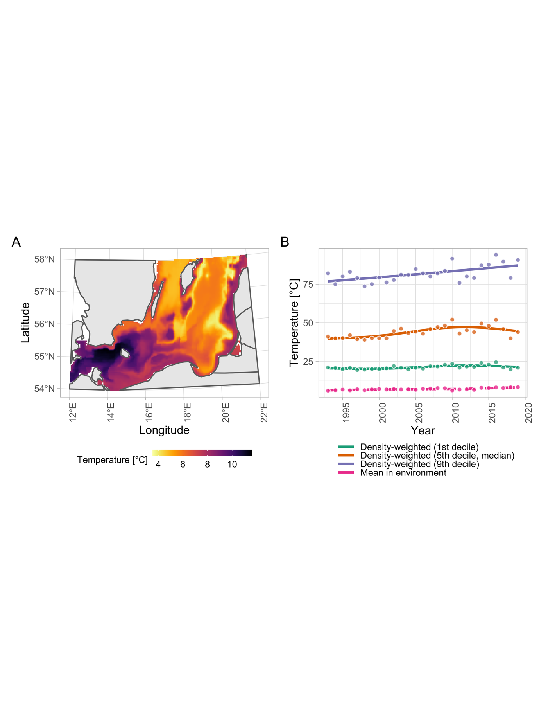

Fig. S19. A) Temperature in space (using year 1999 as an example) (B) temperature weighted by predicted cod density. Lines correspond to the 1st, 5th and 9th decile.

Fig. S20. Placeholder Effect sizes from model fitted to only small cod (<30 cm)

Fig. S21. Placeholder Effect sizes from model fitted to only small cod (>30 cm)

Fig. S22. Placeholder oxygen trends by sub division

Placeholder for cross-validation results